ML Prediction – Project Plan

# Steps behind this project

## Idea:

1. Using TFANN or LSTM model predict closing GE stock price based on the fortune 10 n steps ahead( Days in the future)
   1. Get Date, Close, Volume
   2. Based on user input predict N steps ahead
2. Stretch Goals
   1. Add option for constantly updating the model every time the site is accessed
   2. Allow the user to pick any stock and run it against the model

## Tools to use:

1. API
   1. <https://polygon.io/docs/getting-started>
2. Javascript Libraries
   1. Plot.ly [Plotly: The front end for ML and data science models](https://plotly.com/)
3. Database Backend
   1. Postgres SQL
4. User interaction
   1. Number of days in the future to predict based on user input with a max of 10 days
5. Python Libraries
   1. Numpy
   2. matplotlib
   3. sklearn
   4. tensorflow
      1. LSTM
      2. TFANN
6. Webserver host
   1. Flask
   2. Heroku

## Data sample screenshots:

1. Litecoin

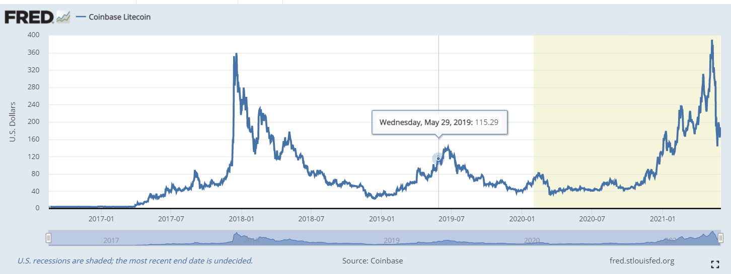

1. Ethereum

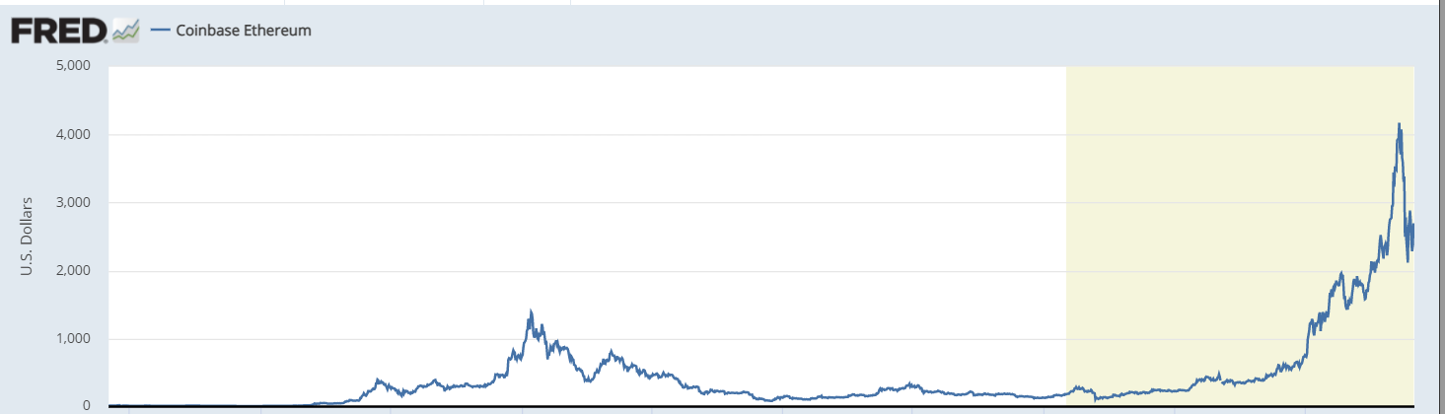

1. Bitcoin

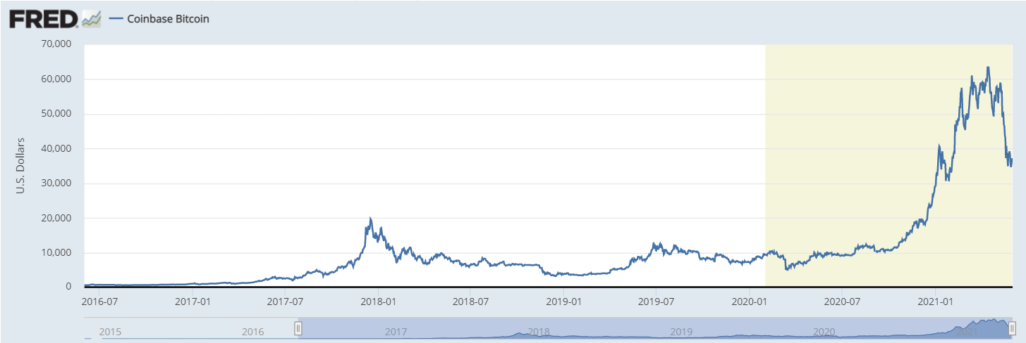

## Repo Location:

1. <https://github.com/gt-data-bootcamp/project-3>

## Inspirational Image

1. Timeline

   Description automatically generated
2. A picture containing light, night, lit, laser

   Description automatically generated
3. Chart

   Description automatically generated